DEEP LEARNING BASED IMAGE CLASSIFICATION METHODS FOR PREDICTION OF SKIN CANCER

ABSTRACT
Skin disease is a very common disease for humans. In the medical industry detecting skin disease and recognizing its type is a very challenging task. Due to the complexity of human skin texture and the visual closeness effect of the diseases, sometimes it is really difficult to detect the exact type. Therefore, it is necessary to detect and recognize the skin disease at its very first observation. In today's era, artificial intelligence (AI) is rapidly growing in medical fields. The CNN model was used by applying transfer learning on the 7 skin diseases to create a skin disease classification system on DL system. The proponents gathered a total of 3,406 images and it is considered as imbalanced dataset because of the unequal number of images on its classes. Furthermore, a web application is designed for instant and proper action. It helps the patient and dermatologists identify the type of disease from the affected region’s image at the initial stage of the skin disease. These findings suggest that the proposed system can help general practitioners efficiently and effectively diagnose skin conditions, thereby reducing further complications and morbidity

TABLE OF CONTENTS
CHAPTER NO. | TITLE | PAGE NO.
 | ABSTRACT | 1
1. | CHAPTER 1 : INTRODUCTION  - GENERAL  1.1.1 THE MACHINE LEARNING SYSTEM  1.1.2 FUNDAMENTAL  1.2 JUPYTER  1.3 MACHINE LEARNING  1.4 CLASSIFICATION TECHNIQUES  1.4.1 NEURAL NETWORK AND DEEP LEARNING  1.4.2 METHODOLOGIES - GIVEN INPUT AND EXPECTED OUTPUT  - OBJECTIVE AND SCOPE OF THE PROJECT  1.6 EXISTING SYSTEM  1.6.1 DISADVANTAGES OF EXISTING SYSTEM  1.6.2 LITERATURE SURVEY  1.7 PROPOSED SYSTEM  1.7.1 PROPOSED SYSTEM ADVANTAGES | 4  6  9  12  12  13  17  17
2. | CHAPTER 2 :PROJECT DESCRIPTION  2.1 INTRODUCTION  2.2 DETAILED DIAGRAM  2.2.1 FRONT END DESIGN  2.2.2 BACK END FLOW  2.3 SOFTWARE SPECIFICATION  2.3.1 HARDWARE SPECIFICATION  2.3.2 SOFTWARE SPECIFICATION  2.4 MODULE DESCRIPTION  2.4.1 DATA PRE PROCESSING  2.4.2 DATA CLEANING  2.4.3 DATA SPLITTING  2.4.4 TRAINING AND TESTING  2.5 MODULE DIAGRAM  2.5.1 SYSEM ARCTHITURE  2.5.2 USECASE DIAGRAM  2.5.3 CLASS DIAGRAM  2.5.4 ACTIVITY DIAGRAM  2.5.5 SEQUENCE DIAGRAM | 37  38  39  39  40  40  40  40  41  41  41  43  44  44  45
3. | CHAPTER 3 : SOFTWARE SPECIFICATION  3.1 general  3.2 ANACONDA  3.3 PYTHON  3.2.1 SCIENTIFIC AND NUMERIC COMPUTING  3.2.2 CREATING SOFTWARE PROTOTYPES  3.2.3 GOOD LANGUAGE TO TEACH PROGRAMMING | 46  46  49  51  51  51
4. | CHAPTER 4 : IMPLEMENTATION  4.1 GENERAL  4.2 IMPLEMENTATION CODING  4.3 SNAPSHOTS | 52  52  58
5. | CHAPTER 5 : CONCLUSION & REFERENCES  5.1 CONCLUSION  5.2 APPLICATION  5.3 REFERENCES | 64  64  64

EXISTING SYSTEM
Towards automated skin disease classification, Kawahara et al. employed ANNs to extract features and trained a linear classifier on them using 1300 images of Dermofit Image Library to perform 10-ary classification. Similar approach was used by Ge et al. on MoleMap dataset to do 15-ary classification. Esteva et al. used a pre-trained Inception v3 on around 130,000 images. Although their results for two binary-classification tasks are merely “on par with all tested experts”, yet this work was the first credible proof-of-concept based on a large dataset that DL can make a practical contribution in real-world diagnosis.. Zilong et al. review the few techniques for skin cancer detection using images. This study was not limited to melanoma detection, it provides an over about different types of cancers that use images for their diagnosis. Few studies for melanoma diagnosis were included in this paper. In addition to this, a review presented by Sultana et a provides an overview of a few deep learning methods and discusses some benchmark datasets. However, it did not give information about non published, internet collected and combine datasets. Another systematic literature on classifying a skin lesion using CNNs by Brinker et al. has been done, it provides a brief overview of the different methods of deep learning.
DRAWBACK:
- Lower accuracy
- Feature extraction is not done properly
- Time consumption for training the model is high
- Complexity is high

PROPOSED SYSTEM
In this paper, a image classification methods for diagnosis of skin cancer on architecture Convolutional neural network (CNN) is proposed for classifying the skin cancer .The proposed method consists of four major steps: pre-processing, Data augumentation pulmonary nodule feature extraction and classifier.

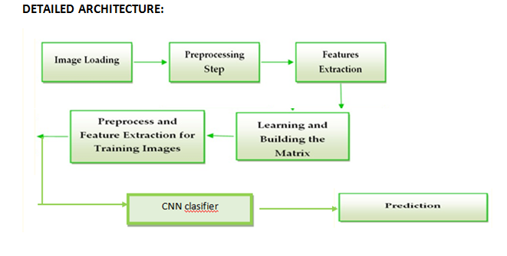 METHOD USED
Convolutional neural network (CNN) & VGG16
SYSTEM REQUIREMENT
SOFTWARE REQUIREMENTS
IDE : Anaconda jupyter
Programming Language : python
HARDWARE REQUIREMENTS
PROCESSOR : Intel (R) Core (TM) i5-2450M
CPU : 2.50 GHz.
RAM : 8 GB RAM
HARD DISK : 250 GB

CHAPTER I
INTRODUCTION
1.2Jupyter

Jupyter, previously known as IPython Notebook, is a web-based, interactive development environment. Originally developed for Python, it has since expanded to support over 40 other programming languages including Julia and R.
Jupyter allows for notebooksto be written that contain text, live code, images, and equations. These notebooks can be shared, and can even be hosted on GitHubfor free.
For each section of this tutorial, you can download a Juypter notebook that allows you to edit and experiment with the code and examples for each topic. Jupyter is part of the Anaconda distribution; it can be started from the command line using the jupyter command:
1.3 Machine Learning
We will now move on to the task of machine learning itself. In the following sections we will describe how to use some basic algorithms, and perform regression, classification, and clustering on some freely available medical datasets concerning breast cancer and diabetes, and we will also take a look at a DNA microarray dataset.

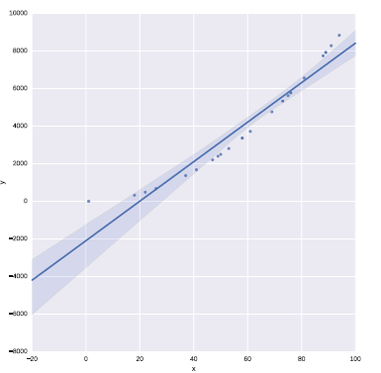

SciKit-Learn
SciKit-Learn provides a standardised interface to many of the most commonly used machine learning algorithms, and is the most popular and frequently used library for machine learning for Python. As well as providing many learning algorithms, SciKit-Learn has a large number of convenience functions for common preprocessing tasks (for example, normalisation or k-fold cross validation).
SciKit-Learn is a very large software library.
Clustering
Clustering algorithms focus on ordering data together into groups. In general clustering algorithms are unsupervised—they require no y response variable as input. That is to say, they attempt to find groups or clusters within data where you do not know the label for each sample. SciKit-Learn have many clusteringalgorithms, but in this section we will demonstrate hierarchical clustering on a DNA expression microarray dataset using an algorithm from the SciPy library.
We will plot a visualisation of the clustering using what is known as a dendrogram, also using the SciPy library.
The goal is to cluster the data properly in logical groups, in this case into the cancer types represented by each sample’s expression data. We do this using agglomerative hierarchical clustering, using Ward’s linkage method:
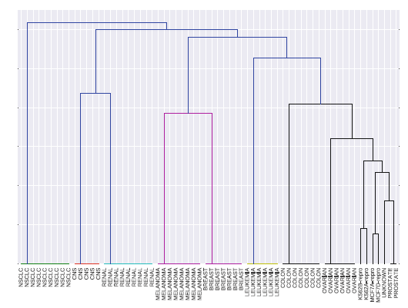
1.4Classification

weanalysed data that was unlabelled—we did not know to what class a sample belonged (known as unsupervised learning). In contrast to this, a supervised problem deals with labelled data where are aware of the discrete classes to which each sample belongs. When we wish to predict which class a sample belongs to, we call this a classification problem. SciKit-Learn has a number of algorithms for classification, in this section we will look at the Support Vector Machine.
We will work on the Wisconsin breast cancer dataset, split it into a training set and a test set, train a Support Vector Machine with a linear kernel, and test the trained model on an unseen dataset. The Support Vector Machine model should be able to predict if a new sample is malignant or benign based on the features of a new, unseen sample:
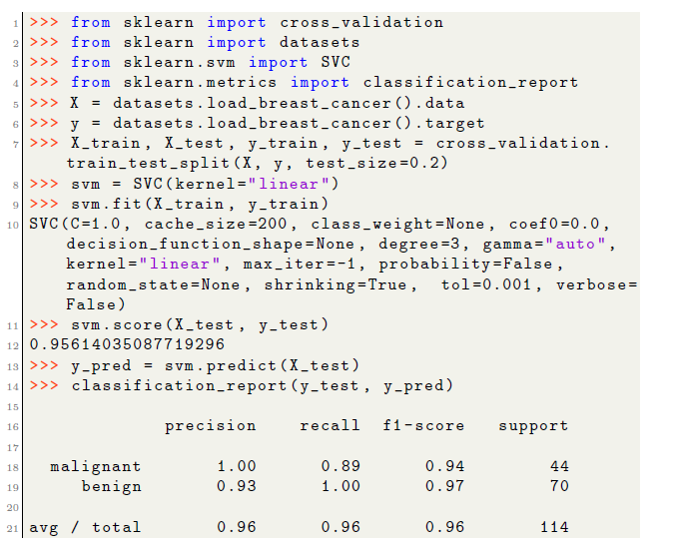
You will notice that the SVM model performed very well at predicting the malignancy of new, unseen samples from the test set—this can be quantified nicely by printing a number of metrics using the classification report function. Here, the precision, recall, and F1 score (F1 = 2· precision·recall/precision+recall) for each class is shown. The support column is a count of the number of samples for each class.
Support Vector Machines are a very powerful tool for classification. They work well in high dimensional spaces, even when the number of features is higher than the number of samples. However, their running time is quadratic to the number of samples so large datasets can become difficult to train. Quadratic means that if you increase a dataset in size by 10 times, it will take 100 times longer to train.
Last, you will notice that the breast cancer dataset consisted of 30 features. This makes it difficult to visualize or plot the data. To aid in visualization of highly dimensional data, we can apply a technique called dimensionality reduction.

Dimensionality Reduction
Another important method in machine learning, and data science in general, is dimensionality reduction. For this example, we will look at the Wisconsin breast cancer dataset once again. The dataset consists of over 500 samples, where each sample has 30 features. The features relate to images of a fine needle aspirate of breast tissue, and the features describe the characteristics of the cells present in the images. All features are real values. The target variable is a discrete value (either malignant or benign) and is therefore a classification dataset.
You will recall from the Iris example in Sect. 7.3 that we plotted a scatter matrix of the data, where each feature was plotted against every other feature in the dataset to look for potential correlations (Fig. 3). By examining this plot you could probably find features which would separate the dataset into groups. Because the dataset only had 4 features we were able to plot each feature against each other relatively easily. However, as the numbers of features grow, this becomes less and less feasible, especially if you consider the gene expression example in Sect. 9.4 which had over 6000 features.
One method that is used to handle data that is highly dimensional is Principle Component Analysis, or PCA. PCA is an unsupervised algorithm for reducing the number of dimensions of a dataset. For example, for plotting purposes you might want to reduce your data down to 2 or 3 dimensions, and PCA allows
you to do this by generating components, which are combinations of the original features, that you can then use to plot your data.
PCA is an unsupervised algorithm. You supply it with your data, X, and you specify the number of components you wish to reduce its dimensionality to. This is known as transforming the data:
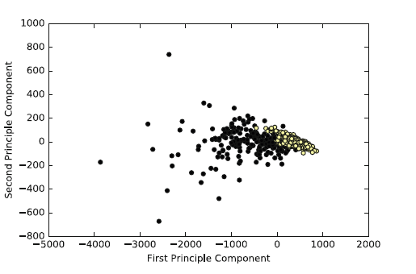
Again, you would not use this model for new data—in a real world scenario, you would, for example, perform a 10-fold cross validation on the dataset, choosing the model parameters that perform best on the cross validation. This model would be much more likely to perform well on new data. At the very least, you would randomly select a subset, say 30% of the data, as a test set and train the model on the remaining 70% of the dataset. You would evaluate the model based on the score on the test set and not on the training set
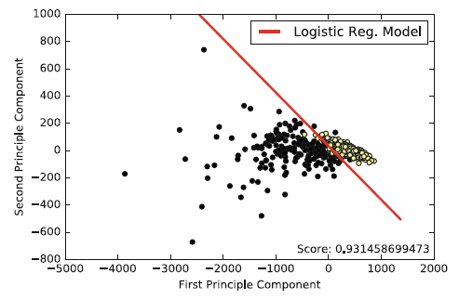.

1.4.1 NEURAL NETWORKS AND DEEP LEARNING
While a proper description of neural networks and deep learning is far beyond the scope of this chapter, we will however discuss an example use case of one of the most popular frameworks for deep learning: Keras4.
In this section we will use Keras to build a simple neural network to classify theWisconsin breast cancer dataset that was described earlier. Often, deep learning algorithms and neural networks are used to classify images—convolutional neural networks are especially used for image related classification. However,
they can of course be used for text or tabular-based data as well. In this we will build a standard feed-forward, densely connected neural network and classify a text-based cancer dataset in order to demonstrate the framework’susage.
In this example we are once again using the Wisconsin breast cancer dataset, which consists of 30 features and 569 individual samples. To make it more challenging for the neural network, we will use a training set consisting of only 50% of the entire dataset, and test our neural network on the remaining 50% of the data.
Note,Keras is not installed as part of the Anaconda distribution, to install it use pip:
Keras additionally requires either Theano or TensorFlow to be installed. In the examples in this chapter we are using Theano as a backend, however the code will work identically for either backend. You can install Theano using pip, but it has a number of dependencies that must be installed first. Refer to the Theano and TensorFlow documentation for more information [12].
Keras is a modular API. It allows you to create neural networks by building a stack of modules, from the input of the neural network, to the output of the neural network, piece by piece until you have a complete network. Also, Keras can be configured to use your Graphics Processing Unit, or GPU. This makes training neural networks far faster than if we were to use a CPU. We begin by importing Keras:
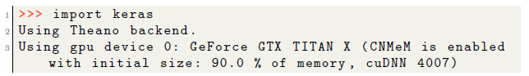
We may want to view the network’s accuracy on the test (or its loss on the training set) over time (measured at each epoch), to get a better idea how well it is learning. An epoch is one complete cycle through the training data.
Fortunately, this is quite easy to plot as Keras’ fit function returns a history object which we can use to do exactly this:
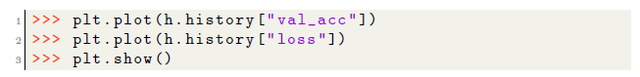
This will result in a plot similar to that shown. Often you will also want to plot the loss on the test set and training set, and the accuracy on the test set and training set.
Plotting the loss and accuracy can be used to see if you are over fitting (you experience tiny loss on the training set, but large loss on the test set) and to see when your training has plateaued.

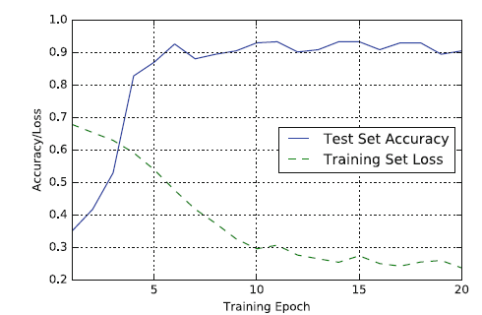

PROBLEM STATEMENT:
The only shortcoming faced during the implementation of the algorithm to predict the skin disease the unavailability of the larger dataset than used. If a larger dataset was available then
the neural network would have been trained more accurately and the results would have been more precise than they presently are. When a much larger dataset is available then CNN could be applied and the epochs and hidden layers could be increased which would increase the accuracy and precision of the outcome provided by the neural network.

1.5 OBJECTIVE STATEMENT:

Skin Disease a life-threatening cessation of activity in the skin. Early prediction of Skins Disease important, as it allows for the necessary measures to be taken to prevent or intervene during the onset. Artificial intelligence (AI) technologies and big data have been increasingly used to enhance the ability to predict and prepare for the patients at risk.This study aims to explore the use of AI technology in predicting skin disease as reported in the literature.
SCOPE OF THE PROJECT:

Skin Disease and other Skin diseases are the most common problem in majority of people, and there are various factors that act as backbone of this problem like people are not paying attention towards health mainly because of work stress, laziness, substandard quality of food that results in increasing cholesterol and untimely diagnosis of heart disease due to lack of technology, methods used in diagnosing these diseases and consequently having a lot of tests. A lot of research and medical supporting systems are developing day by day, however, every system have its various features or advantages and limitations which are unknown to either side. This paper aims to study different machine learning algorithms on dataset to predict the possibility of a cardiac arrest based on various controlled and uncontrolled variables.

1.6 EXISTING SYSTEM
Towards automated skin disease classification, Kawahara et al. employed ANNs to extract features and trained a linear classifier on them using 1300 images of Dermofit Image Library to perform 10-ary classification. Similar approach was used by Ge et al. on MoleMap dataset to do 15-ary classification. Esteva et al. used a pre-trained Inception v3 on around 130,000 images. Although their results for two binary-classification tasks are merely “on par with all tested experts”, yet this work was the first credible proof-of-concept based on a large dataset that DL can make a practical contribution in real-world diagnosis.. Zilong et al. review the few techniques for skin cancer detection using images. This study was not limited to melanoma detection, it provides an over about different types of cancers that use images for their diagnosis. Few studies for melanoma diagnosis were included in this paper. In addition to this, a review presented by Sultana et a provides an overview of a few deep learning methods and discusses some benchmark datasets. However, it did not give information about non published, internet collected and combine datasets. Another systematic literature on classifying a skin lesion using CNNs by Brinker et al. has been done, it provides a brief overview of the different methods of deep learning.

DRAWBACK:
- Lower accuracy
- Feature extraction is not done properly
- Time consumption for training the model is high
- Complexity is high

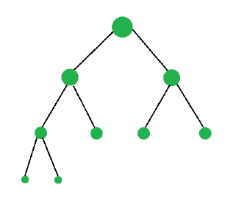
1.6.1 DISADVANTAGES OF EXISTING SYSTEM
- Several risk scoring systems are used to identify patients at high risk of serious adverse events including unexpected inpatient death
- Accuracy low
- Cardiovascular disease and cancer are leading causes of morbidity and mortality, and can both be present in one patient. In patients with simultaneous disease, the most threatening disease should be treated first.
- Improved depression scores , and decreased health care utilization
- It may increase death rate .

1.6.2 LITERATURE SURVEY

1.TITLE: Prediction of In-Hospital Cardiac Arrest Using Shallow and Deep Learning
Author: Minsu Chae , Sangwook Han , Hyowook Gil , Namjun Cho and Hwamin Lee
Year:2021

Abstract:
Sudden cardiac arrest can leave serious brain damage or lead to death, so it is very important to predict before a cardiac arrest occurs. However, early warning score systems including the National Early Warning Score, are associated with low sensitivity and false positives. We applied shallow and deep learning to predict cardiac arrest to overcome these limitations. We evaluated the performance of the Synthetic Minority Oversampling Technique Ratio. We evaluated the performance using a Decision Tree, a Random Forest, Logistic Regression, Long Short-Term Memory model, Gated Recurrent Unit model, and LSTM–GRU hybrid models. Our proposed Logistic Regression demonstrated a higher positive predictive value and sensitivity than traditional early warning systems.

2.TITLE: Prediction of cardiac arrest in critically ill patients based on

bedside vital signs monitoring
Author: LiYijinga,YeWenyua,YangKangaZhang,Shengyua,HeXianlianga,JinXinglianga
Year:2021
Abstract:

Despite advances in healthcare, the incidence of in-hospital cardiac arrest (IHCA) has continued to rise for the past decade. Identifying those patients at risk has proven challenging. Our objective was to conduct a systematic review of the literature to compare the IHCA predictive performance of machine learning (ML) models with the Modified Early Warning Score (MEWS). Design: The systematic review was conducted following the Preferred Reporting Items of Systematic Review and Meta-Analysis guidelines and registered on Method: Data extraction was completed using the Critical Appraisal and Data Extraction for Systematic Reviews of Prediction Modeling Studies checklist. The risk of bias and applicability were evaluated using the Prediction model Risk of Bias Assessment Tool. Results: Nine articles were included in this review that developed or validated IHCA prediction models and compared them with the MEWS. The studies by Jang et al and Kim et al showed that their ML models outperformed MEWS to predict IHCA with good to excellent predictive performance. Conclusions: The ML models presented in this systematic review demonstrate a novel approach to predicting IHCA. All included studies suggest that ML models had similar or better predictive performance compared with MEWS. However, there is substantial variability in performance measures and concerns for risk of bias.

3.TITLE: An Algorithm Based on Deep Learning for Predicting In‐Hospital Cardiac Arrest

Author: Joon-Myoung Kwon, Youngnam Lee

Year:2021

Abstract:

In-hospital cardiac arrest is a major burden to public health, which affects patient safety. Although traditional track-and-trigger systems are used to predict cardiac arrest early, they have limitations, with low sensitivity and high false-alarm rates. We propose a deep learning-based early warning system that shows higher performance than the existing track-and-trigger systems. Methods and results: This retrospective cohort study reviewed patients who were admitted to 2 hospitals from June 2010 to July 2017. A total of 52 131 patients were included. Specifically, a recurrent neural network was trained using data from June 2010 to January 2017. The result was tested using the data from February to July 2017. The primary outcome was cardiac arrest, and the secondary outcome was death without attempted resuscitation. As comparative measures, we used the area under the receiver operating characteristic curve (AUROC), the area under the precision-recall curve (AUPRC), and the net reclassification index. Furthermore, we evaluated sensitivity while varying the number of alarms. The deep learning-based early warning system (AUROC: 0.850; AUPRC: 0.044) significantly outperformed a modified early warning score (AUROC: 0.603; AUPRC: 0.003), a random forest algorithm (AUROC: 0.780; AUPRC: 0.014), and logistic regression (AUROC: 0.613; AUPRC: 0.007). Furthermore, the deep learning-based early warning system reduced the number of alarms by 82.2%, 13.5%, and 42.1% compared with the modified early warning system, random forest, and logistic regression, respectively, at the same sensitivity. Conclusions: An algorithm based on deep learning had high sensitivity and a low false-alarm rate for detection of patients with cardiac arrest in the multicenter study.

4.TITLE: Machine Learning Models for Survival and Neurological Outcome Prediction of Out-of-Hospital Cardiac Arrest Patients
Author: Chi-Yung Cheng, I-Min Chiu, Wun-Huei Zeng, Chih-Min Tsai and Chun-Hung Richard Lin
Year:2021
Abstract:
Out-of-hospital cardiac arrest (OHCA) is a major health problem worldwide, and neurologic injury remains the leading cause of morbidity and mortality among survivors of OHCA. The purpose of this study was to investigate whether a machine learning algorithm could detect complex dependencies between clinical variables in emergency departments in OHCA survivors and perform reliable predictions of favorable neurologic outcomes. Methods. This study included adults (≥18 years of age) with a sustained return of spontaneous circulation after successful resuscitation from OHCA between 1 January 2004 and 31 December 2014. We applied three machine learning algorithms, including logistic regression (LR), support vector machine (SVM), and extreme gradient boosting (XGB). The primary outcome was a favorable neurological outcome at hospital discharge, defined as a Glasgow-Pittsburgh cerebral performance category of 1 to 2. The secondary outcome was a 30-day survival rate and survival-to-discharge rate.

5.TITLE: Machine learning model for predicting out-of-hospital cardiac arrests using meteorological and chronological data
Author: Takahiro Nakashima, Soshiro ,Teruo Noguchi, Yoshio Tahara
Year:2020
Abstract:
To evaluate a predictive model for robust estimation of daily out-of-hospital cardiac arrest (OHCA) incidence using a suite of machine learning (ML) approaches and high-resolution meteorological and chronological data.In this population-based study, we combined an OHCA nationwide registry and high-resolution meteorological and chronological datasets from Japan. We developed a model to predict daily OHCA incidence with a training dataset for 2005–2013 using the eXtreme Gradient Boosting algorithm. A dataset for 2014–2015 was used to test the predictive model. The main outcome was the accuracy of the predictive model for the number of daily OHCA events, based on mean absolute error (MAE) and mean absolute percentage error (MAPE). In general, a model with MAPE less than 10% is considered highly accurate.Among the 1 299 784 OHCA cases, 661 052 OHCA cases of cardiac origin (525 374 cases in the training dataset on which fourfold cross-validation was performed and 135 678 cases in the testing dataset) were included in the analysis. Compared with the ML models using meteorological or chronological variables alone, the ML model with combined meteorological and chronological variables had the highest predictive accuracy in the training (MAE 1.314 and MAPE 7.007%) and testing datasets (MAE 1.547 and MAPE 7.788%). Sunday, Monday, holiday, winter, low ambient temperature and large interday or intraday temperature difference were more strongly associated with OHCA incidence than other the meteorological and chronological variables.

1.7PROPOSED SYSTEM
Cardiac arrest (CA) is the most serious death-related event in critically ill patients and the early detection of CA is beneficial to reduce mortality according to clinical research. This study aims to develop and verify a real-time, interpretable machine learning model, namely cardiac arrest prediction index (CAPI), to predict CA of critically ill patients based on bedside vital signs monitoring.
The proposed convolutional architecture contains the input layer followed by a convolutional layer with 16 kernels along with activation function as ReLU, in the subsequent layer 25% of the nodes is dropped by dropout layer. Again, the convolutional layer was performed with eight kernels with previous parameters, also applied the dropout layer with 25%. For prediction probability calculations, added an output layer.
The cleaned data is split into 80% training and 20% testing for training and testing purposes. The same dataset is tested with different deep learning classifiers such as VGG16 & CNN. In this paper, we proposed a CNN to predict the accuracy of whether a patient had a cardio arrest or not. 89.91 training accuracy and 86.83% testing accuracy

1.7.1 PROPOSED SYSTEM ADVANTAGES
- Increased accuracy for effective cardiac arrest diagnosis.
- Handles roughest (enormous) amount of data using random forest algorithm and feature selection.
- Reduce the time complexity of doctors.
Cost effective for patients

CHAPTER II
PROJECT DESCRIPTION
Skin lesions are abnormalities in the surface of the skin. They are good markers of life quality and even are symptoms of deadly diseases. Since professional medical help can be inaccessible for some people due to shortage of professional dermatologists or high cost of professional help, development of tools for automated diagnostics of dermatological diseases could be beneficial for the humanity and could provide low-cost medical help around the world. Visual information is the primary source for dermatological disease diagnostics, therefore it is possible to create automated dermatological disease diagnostics tools by analyzing skin images using methods of computer vision and machine learning.

A promising approach to skin disease diagnosis is through identification of morphological elements in the affected skin [1], which later are used in diagnostics [2]. The crucial advantage of using morphological elements is their number, because there are only some of them in comparison with the number of diseases causing them. The more classes should be distinguished, the more labeled data is required to apply modern machine learning methods. However, availability of labeled medical data is widely acknowledged bottleneck.

Morphological elements are divided into primary and secondary ones. Primary morphology refers to the appearance characteristics of a skin lesion while secondary morphology refers to the temporal changes in the skin lesion [3]. Therefore, primary morphology is more indicative of a skin lesion structure and appearance and identifying primary morphological elements is a priority

Although skin morphology is widely discussed in dermatology studies, different specialists tend to choose slightly different classification for their research. Most of existing classifications include following types with consistent definitions: macule, patch, papule, nodule, plaque, wheal, vesicle, bulla, and pustule. An example of definitions can be acquired in [4], according to which:
- bulla is a fluid-filled circumscribed elevation of skin that is over 0.5 cm in diameter;
- macule is a small flat area with color or texture differing from surrounding skin;
- nodule is a solid mass in the skin that is palpated or elevated and is, in diameter of both width and depth, greater than 0.5 cm;
- papule is a solid elevation of skin that is less than 0.5 cm in diameter;
- patch is a large flat area with color or texture differing from surrounding skin;
- plaque is an elevated area of skin without substantial depth but is greater than 2 cm in diameter;
- pustule is an evident accumulation of pus in skin;
- vesicle is a fluid-filled circumscribed elevation of skin that is less than 0.5 cm in diameter;
- Wheal is a white elevated compressible and faded area often surrounded by a red flare.
In this research, we propose an end-to-end deep learning solution for the problem of classifying images of skin lesions containing only one primary morphological element of the following: macule, nodule, papule, plaque.
The rest of the paper is organized as follows. In Section II we briefly overview related works devoted to automatic skin lesion diagnostics. Section III describes the collection of our dataset. Section IV explains the deep learning methods we used to solve the task. In Section V we analyze results of our experiments. Section VI summarizes the paper and provides further research directions.

2.2 DETAILED DIAGRAM
DIAGRAMS:
SYSTEM ARCHITECTURE:
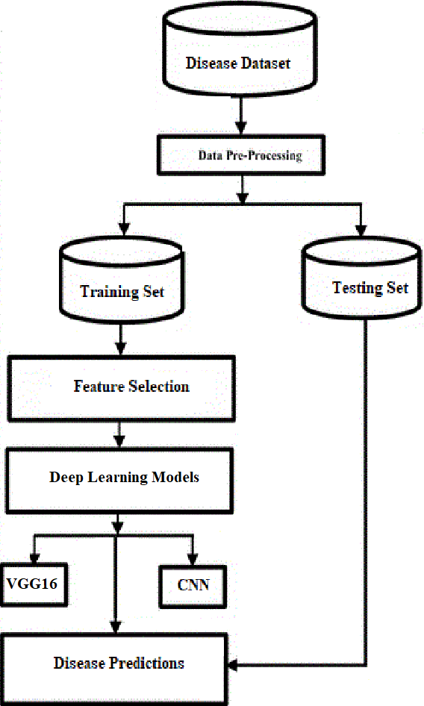
DATA FLOW DIAGRAM:
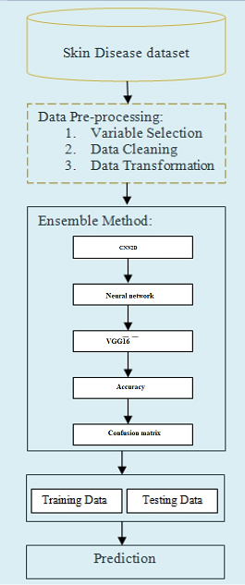

USE CASE DIAGRAM:
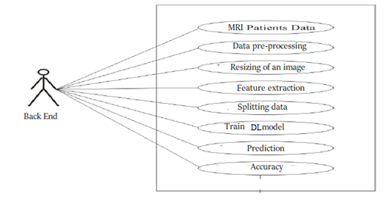
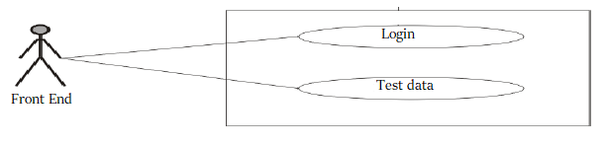
CLASS DIAGRAM:
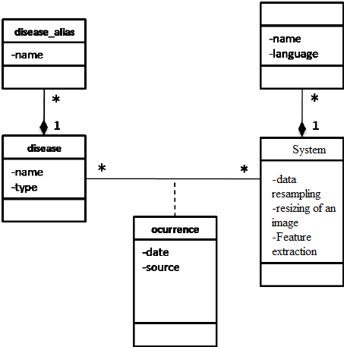
COLLOBORTIVE DIAGRAM:
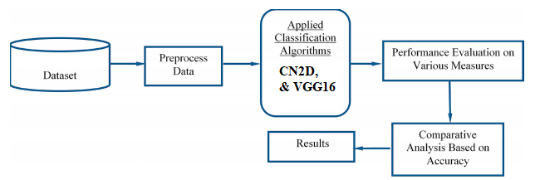

USECASE DIAGRAM:
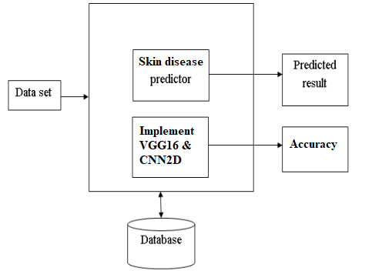
SEQUENCE DIAGRAM:
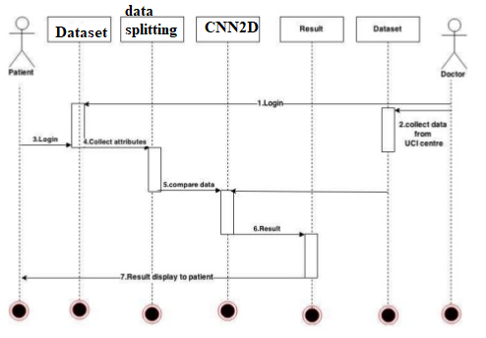

ACTIVITY DIAGRAM:
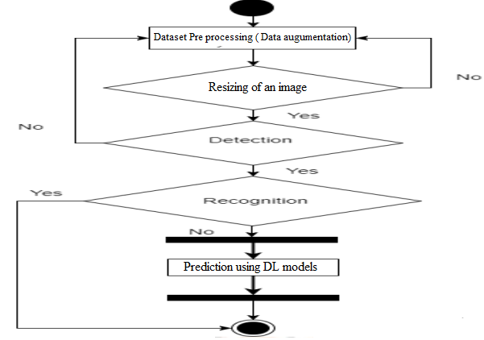

MODULES
Data collection:
This dataset consists of 10015 dermatoscopic images categorized into 7 different classes. A complete dataset is employed to train the system model. A dataset is split into training set and validating/testing set. Validation/testing set will tune the parameters and is used only to assess the effectiveness and efficiency of the system.
Labels: Labels are the last yield. The yield classes is likely to be the 1names. When information researchers discuss marked information, they mean the gatherings of tests that have been labelled to at least one name.
Overfitting: A significant thought in Deep Learning is that the estimation of the objective capacity that has been prepared utilizing preparing information, sums up to new information. Speculation works best if the sign or the example that is utilized as the preparation information has a high sign to commotion proportion.
Data Preprocessing
The methodology proposed in this research paper starts with data preprocessing. Data preprocessing step includes (i) a data driven method to select patient records and selecting important variables for analysis and (ii) The collected data from patient records are not clean and may include noise, incorrect, missing values, or inconsistent data. So we have to apply different method of data cleaning to clean such anomalies. (iii) The data are not ready for mining even after cleaning, because they are in different formats, which directly can’t be used, so data must be transform into formats suitable for mining. The transformation applied to achieve this is normalization; smoothing, aggregation, etc. are used.
Data splitting

For each experiment, we split the entire dataset into 70% training set and 30% test set. We
used the training set for resampling, hyper parameter tuning, and training the model and we used test set to test the performance of the trained model. While splitting the data, we specified a random seed (any random number), which ensured the same data split every time the program executed.

- Splitting of data
After cleaning the data, data is normalized in training and testing the model. When data is spitted then we train algorithm on the training data set and keep test data set aside. This training process will produce the training model based on logic and algorithms and values of the feature in training data. Basically aim of feature extraction is to bring all the values under same scale.
A dataset used for machine learning should be partitioned into three subsets — training, test, and validation sets.
Training set: -A data scientist uses a training set to train a model and define its optimal parameters — parameters it has to learn from data.
Test set: - A test set is needed for an evaluation of the trained model and its capability for generalization. The latter means a model’s ability to identify patterns in new unseen data after having been trained over a training data. It’s crucial to use different subsets for training and testing to avoid model over fitting, which is the incapacity for generalization we mentioned above.
NEURALNETWORK:
A neural network[5] consists of multiple neuron-like structures. The input image is feed to multiple neurons. The output we get is a single classified one. Various computations are taken place in the intermediate neurons The layers with intermediate neurons are known as Hidden Layers The weights are added for the proper output. In the neural network, the final output is known, so if the calculated output is wrong a back propagation is made and the approximate weights are updated. The activation function is used to speed up the process. In this, we use three convolutional neural network models. Convolutional neural networks are a subclass of neural networks. They are great at capturing local information and predicting based on trained data. We use three models namely Inception__v3, Mobile Net, Res net. The weights [5] of all the three models are taken from ImageNet website
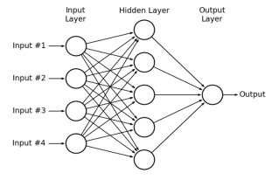
VGG16 model:
Transfer learning generally refers to a process where a model trained on one problem is used in some way on a second related problem. In deep learning, transfer learning is a technique whereby a neural network model is first trained on a problem similar to the problem that is being solved. One or more layers from the trained model are then used in a new model trained on the problem of interest.
Transfer learning has the benefit of decreasing the training time for a neural network model and can result in lower generalization error.
The weights in re-used layers may be used as the starting point for the training process and adapted in response to the new problem. This usage treats transfer learning as a type of weight initialization scheme. This may be useful when the first related problem has a lot more labeled data than the problem of interest and the similarity in the structure of the problem may be useful in both contexts.
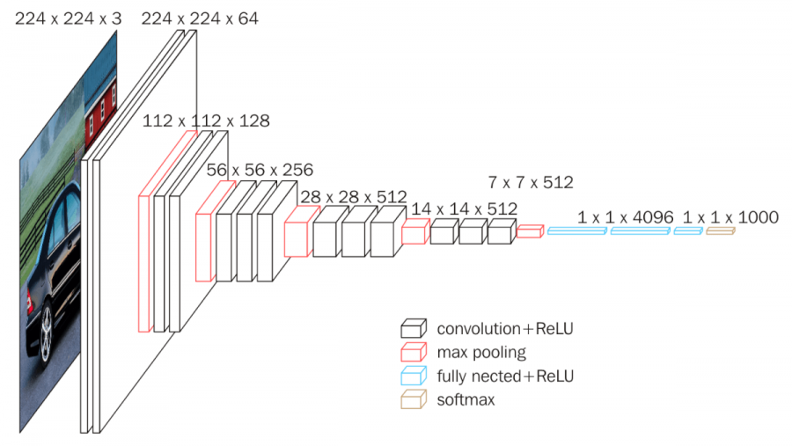
PERFORMANCE MATRICES:
Data was divided into two portions, training data and testing data, both these portions consisting 70% and 30% data respectively. All these six algorithms were applied on same dataset using Enthought Canaopy and results were obtained.
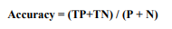
Predicting accuracy is the main evaluation parameter that we used in this work. Accuracy can be defied using equation. Accuracy is the overall success rate of the algorithm.
CONFUSION MATRIX:

It is the most commonly used evaluation metrics in predictive analysis mainly because it is very easy to understand and it can be used to compute other essential metrics such as accuracy, recall, precision, etc. It is an NxN matrix that describes the overall performance of a model when used on some dataset, where N is the number of class labels in the classification problem.
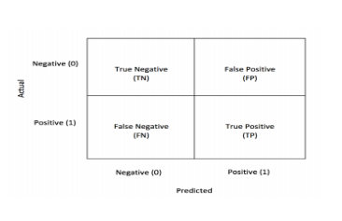
All predicted true positive and true negative divided by all positive and negative. True Positive (TP), True Negative (TN), False Negative (FN) and False Positive (FP) predicted by all algorithms are presented in table.
True positive (TP) indicates that the positive class is predicted as a positive class, and the number of sample positive classes was actually predicted by the model.
False negative indicates (FN) that the positive class is predicted as a negative class, and the number of negative classes in the sample was actually predicted by the model.
False positive (FP) indicates that the negative class is predicted as a positive class, and the number of positive classes of samples was actually predicted by the model.
True negative (TN) indicates that the negative class is predicted as a negative class, and the number of sample negative classes was actually predicted by the model.
REFERENCES:
- W. James, T. Berger, and D. Elston, Andrews’ Diseases of the Skin, 11st ed. Saunders, 2011.
- Garg, N. A. Levin, and J. D. Bernhard, Fitzpatrick’s Dermatology in General Medicine. New York, NY: McGraw-Hill.
- J. Bolognia, J. Jorizzo, J. Schaffer, J. Callen, L. Cerroni,W. Heymann, G. Hruza, A. Mancini, J. McGrath, J. Patterson, and T. Schwarz, Dermatology, 3rd edition. Elsevier, 2012.
- R. B. Weller, J. A. A. Hunter, J. Savin, and M. Dahl, Clinical Dermatology, 4th Edition. Wiley-Blackwell, 2013.
- Esteva, B. Kuprel, R. A. Novoa, J. Ko, S. M. Swetter, H. M. Blau, and S. Thrun, “Dermatologist-level classification of skin cancer with deep neural networks,” Nature, vol. 542, pp. 115–118, February 2017.
- D. Gutman, N. C. F. Codella, M. E. Celebi, B. Helba, M. A. Marchetti, N. K. Mishra, and A. Halpern, “Skin lesion analysis toward melanoma detection: A challenge at the international symposium on biomedical imaging (ISBI) 2016, hosted by the international skin imaging collaboration (ISIC),” CoRR, vol. abs/1605.01397, 2016.
- N. C. F. Codella, D. Gutman, M. E. Celebi, B. Helba, M. A. Marchetti, S. W.Dusza, A. Kalloo, K. Liopyris, N. K. Mishra, H. Kittler, and A. Halpern, “Skin lesion analysis toward melanoma detection: A challenge at the 2017 international symposium on biomedical imaging (isbi), hosted by the international skin imaging collaboration (ISIC),” CoRR, vol. abs/1710.05006, 2017.
- Madooei and M. S. Drew, “A colour palette for automatic detection of blue-white veil,” Color Imaging Conference, 2013.
- P. S. Ambad and A. S. Shirsat, “A image analysis system to detect skin diseases,” IOSR Journal of VLSI and Signal Processing (IOSR-JVSP), vol. 6, pp. 17–25, 2016.
- M. S. Arifin, M. G. Kibria, A. Firoze, M. A. Amin, and Y.- W. Chong, “Dermatological disease diagnosis using color-skin images,” vol. 5, 07 2012, pp. 1675–1680.
- R. Yasir, A. Rahman, and N. Ahmed, “Dermatological disease detection using image processing and artificial neural network,” pp. 687–690, 01 2015.
- J. M. A.Macatangay, C. R. Ruiz, and R. P. Usatine, “A primary morphological classifier for skin lesion images,” http://wscg.zcu.cz/wscg2017/full/I37-full.PDF, accessed 01 Dec 2018.
- L. Torrey and J. Shavlik, “Transfer learning,” 2009.
- K. Simonyan and A. Zisserman, “Very deep convolutional networks for large-scale image recognition,” CoRR, vol.abs/1409.1556, 2014
- A. Capuano, “Extracting features from convolutional neural networks for image retrieval,” https://medium.com/ arocketman/extracting-features-from-convolutional-neuralnetworks-for-image-retrieval-87b5127f8a92, 2018, accessed 01 Dec 2018.
- H.-C. Shin, H. Roth, M. Gao, L. Lu, Z. Xu, I. Nogues, J. Yao, D. J. Mollura, and R. M. Summers, “Deep convolutional neural networks for computer-aided detection: Cnn architectures, dataset characteristics and transfer learning,” IEEE Transactions on Medical Imaging, vol. 35, pp. 1285–1298, 2016.
- S. M. Xie, N. Jean, M. Burke, D. B. Lobell, and S. Ermon, “Transfer learning from deep features for remote sensing and poverty mapping,” CoRR, vol. abs/1510.00098, 2015. [Online]. Available: http://arxiv.org/abs/1510.00098
- I. Loshchilov and F. Hutter, “SGDR: stochastic gradient descent with restarts,” CoRR, vol. abs/1608.03983, 2016.[Online]. Available: http://arxiv.org/abs/1608.03983
- L. N. Smith, “No more pesky learning rate guessinggames,” CoRR, vol. abs/1506.01186, 2015. [Online]. Available: http://arxiv.org/abs/1506.01186

